ABSTRACT TITLE, LEFT ALIGNED, IN CAPS, ARIAL FONT, SIZE 11
All collaborating author names, presenting author, left aligned, ARIAL font, size 10.
All collaborating author affiliations (including city/state & country), left aligned, ARIAL font, size 10. Please add the email address next to the corresponding author’s affiliation.

Your abstract should be no longer than 200words, plus one figure OR one table. Any abstracts exceeding this length may be cut short when publishing the conference abstract booklet. Text should be in ‘Arial’ font, size 10, left aligned.

Separate paragraphs with a line in-between.

If you wish to use graphs or images, please ensure they are included within the page margins so the full image is visible.

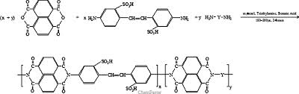

Example figure centred and caption centred in italics…

References
- Please bullet each reference accordingly.
- Please bullet each reference accordingly.
- Please bullet each reference accordingly.

